Exercise 2: E-commerce Platform Search Function
Scenario:
You are working on the search functionality of an e-commerce platform. The search needs to be optimized for fast performance.
Steps:
- Understand Asymptotic Notation:
  - Explain Big O notation and how it helps in analyzing algorithms.
  - Describe the best, average, and worst-case scenarios for search operations.
- Setup:
  - Create a class Product with attributes for searching, such as productId, productName, and category.
- Implementation:
  - Implement linear search and binary search algorithms.
  - Store products in an array for linear search and a sorted array for binary search.
- Analysis:
  - Compare the time complexity of linear and binary search algorithms.
  - Discuss which algorithm is more suitable for your platform and why.
SOLUTION:
public class Product{
private String productId;
private String productName;
private String category;
public Product(String productId, String productName,String category){
this.productId=productId;
this.productName=productName;
this.category=category;
}
public String getProductId() {
return productId;
}

public String getProductName() {
return productName;
}

public String getCategory() {
return category;
}

public String toString() {
return "Product[ID=" + productId + ", Name=" + productName + ", Category=" + category + "]";
}

}
import java.util.Arrays;
public class SearchPlatform{
public static Product linearSearch(Product[] products,String targetId){
for(Product product:products){
if(product.getProductId().equals(targetId)){
return product;
}
}
return null;
}
public static Product binarySearch(Product[] products,String targetId){
int left=0;
int right=products.length-1;
while(left<=right){
int mid=left+(right-left)/2;
int comparision=products[mid].getProductId().compareTo(targetId);
if(comparision==0){
return products[mid];
}
else if(comparision<0){
left=mid+1;
}
else{
right=mid-1;
}
}
return null;
}

public static void main(String[] args) {

Product[] inventory = {
new Product("P105", "Wireless Mouse", "Electronics"),
new Product("P101", "Gaming Laptop", "Electronics"),
new Product("P103", "Coffee Maker", "Appliances"),
new Product("P102", "Running Shoes", "Apparel")
};

Product[] sortedInventory = Arrays.copyOf(inventory, inventory.length);
Arrays.sort(sortedInventory, (p1, p2) -> p1.getProductId().compareTo(p2.getProductId()));

System.out.println("Testing Linear Search");
Product result1 = linearSearch(inventory, "P103");
System.out.println("Result: " + result1);

System.out.println("Testing Binary Search");
Product result2 = binarySearch(sortedInventory, "P103");
System.out.println("Result: " + result2);
}
}
RESULT:
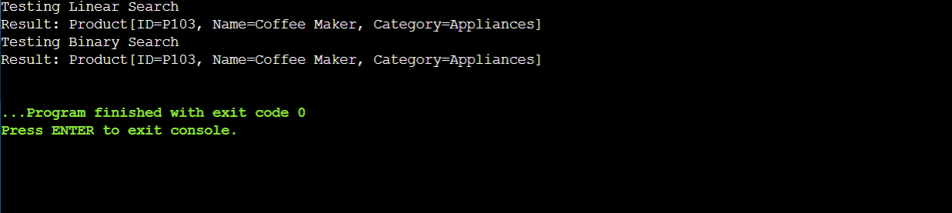
Exercise 7: Financial Forecasting
Scenario:
You are developing a financial forecasting tool that predicts future values based on past data.
Steps:
- Understand Recursive Algorithms:
  - Explain the concept of recursion and how it can simplify certain problems.
- Setup:
  - Create a method to calculate the future value using a recursive approach.
- Implementation:
  - Implement a recursive algorithm to predict future values based on past growth rates.
- Analysis:
  - Discuss the time complexity of your recursive algorithm.
  - Explain how to optimize the recursive solution to avoid excessive computation.

public class FinancialForecaster {

public static double calculateFutureValue(double presentValue, double growthRate, int years) {
if (years == 0) {
return presentValue;
}

return calculateFutureValue(presentValue, growthRate, years - 1) * (1 + growthRate);
}

public static void main(String[] args) {
double principal = 1000.0;
double annualRate = 0.07;
int forecastYears = 5;

double futureValue = calculateFutureValue(principal, annualRate, forecastYears);

System.out.printf("Initial Investment: $%.2f%n", principal);
System.out.printf("Annual Growth Rate: %.1f%%%n", (annualRate * 100));
System.out.printf("Forecasted Value after %d years: $%.2f%n", forecastYears, futureValue);
}
}
RESULT:
